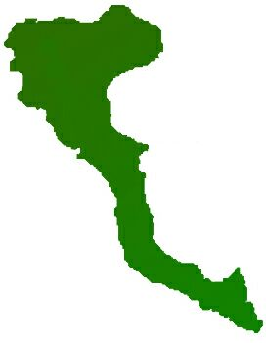

|  |  |  |  |
| --- | --- | --- | --- |
| **Team: 3-D Protocol number: 6** | | | |
|  | | | |
| **Author: Pedro Arenas** | | **Date**: 20.01.2021 | |
| **Place:** MS Teams at 18.30 hrs | |
| **Participants:**  - Adnan, Muhammad  - Arenas, Pedro  - Shahid, Arsalan  - Ur Rehman, Mutee | | | |
| **Protocol of the meeting of 20 December 2020** | | | | |
| **Topic** | **Results** | | **Time** | |
| Project Decisions | Mr. Arenas will be team leader until next change | | 1 min | |
| Task State | Report creation and CMS documentation is still pending | | 1 min | |
|  | Progress on Users control and authentication:   * Keycloak container is able to be launched with the rest of containers * Keycloak is properly configured to be used on both front and backend * Backend is ready to be used together with keycloak * Frontend is configured to be used with keycloak * Frontend Login, Logout and Registration flow are already done. | | 10 min | |
|  | Mr. Adnan is still working on front-end tasks, current state:   * Create contact, footer, genre, header and home components and configure it in the app module (routing) * Configure Routing for new pages * Create Service Methods to call APIs. (_service/movies)   + getTrendingMovies   + getUpcomingMovies   + getNowPlayingMovies   + getMostPopularMovies   + getMostVotedMovies * Create Service methods to call APIs (_service/movies)   + getTvDramaById   + getTvDramaSeasonById   + getTvDramaSeasonAndEpisodes   + getTvDramaSeasonAndEpisodesById | | 10 min | |
|  | Mr. Shahid is still working on searching functionality | | 2 min | |
| Next Tasks | Mr. Arenas will create final report schema and add CMS documentation to it (pending from last week) | | 1 min | |
|  | Next on Users control and authentication – Mr. Arenas   * Configure keycloak css theme with the same look & feel as the frontend * Add Angular AuthGuard * Add Angular HTTPInterceptor | | 1 min | |
|  | Mr. Adnan will work   * Details page for each film/movie * Menu * Create “Most awaited” components. * Resolved issues on the detail page. | |  | |